**PAGINA PRINCIPAL**

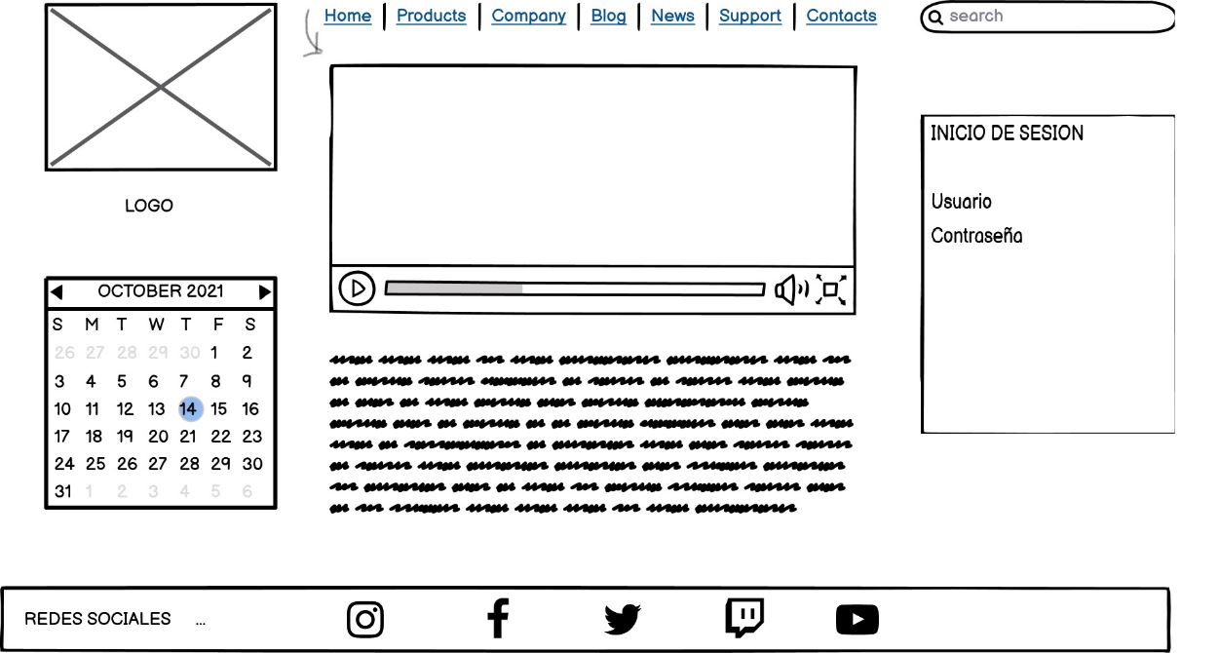

**FORMULARIO REGISTRO**

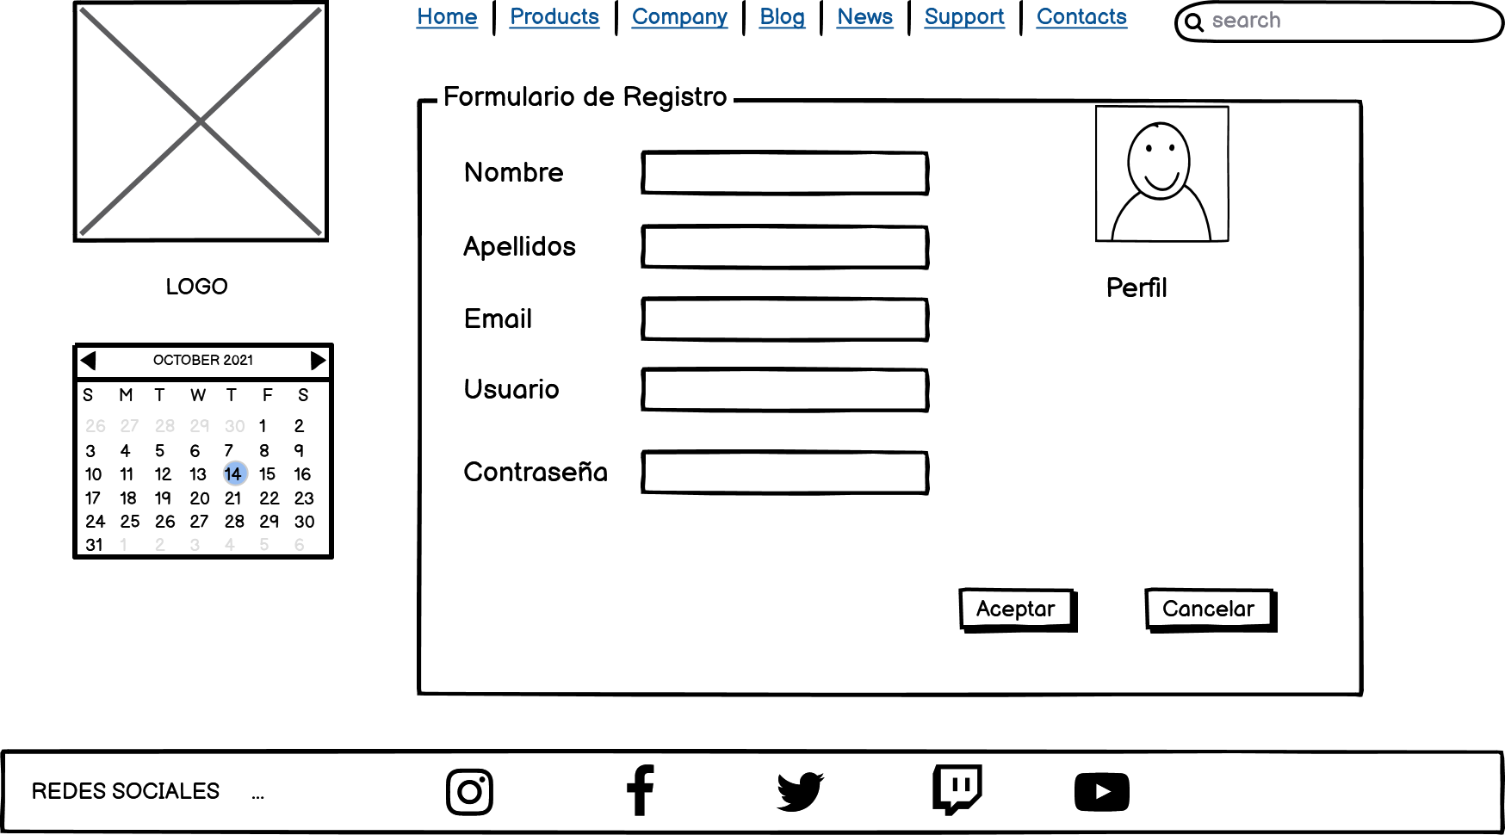

**FORMA RESPONSIVE**

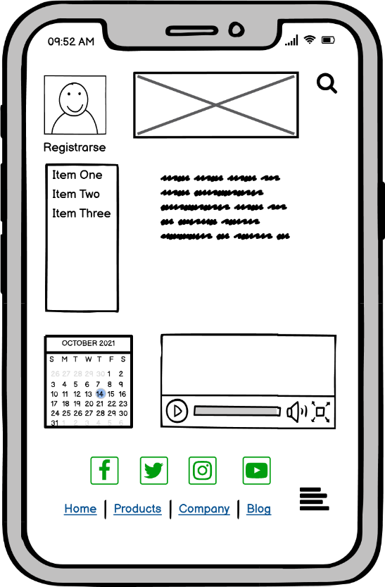

**ADMINISTRADOR RESPONSIVE**

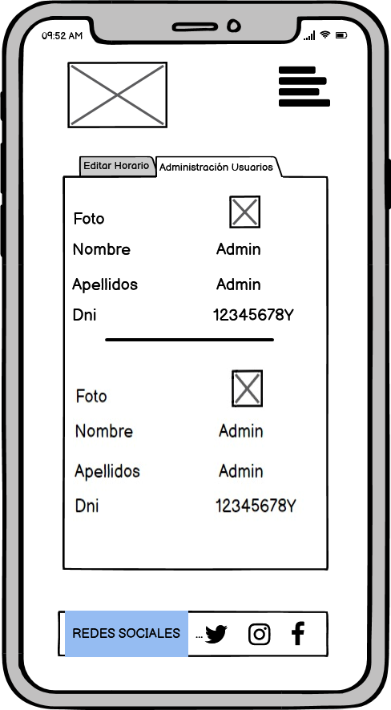

**ENLACE A GITHUB**

<https://github.com/javiergr2001/ELITEGYM>